Shuttle Instructions
A shuttle will be running between Le Meridian Petaling Jaya and Monash University on the conference dates. For each time listed below, one 40-seater shuttle will depart. Please familiarize yourself with the schedule below and plan your shuttle times accordingly. The shuttle is expected to take 20-45 minutes, depending on traffic.

Shuttle Departure and Arrival Locations
Le Méridien Petaling Jaya: Hotel Lobby / Porte Cochère, Located at Level UG.
Monash University Malaysia Campus: Gate A / Monash University Main Entrance (Map Below)
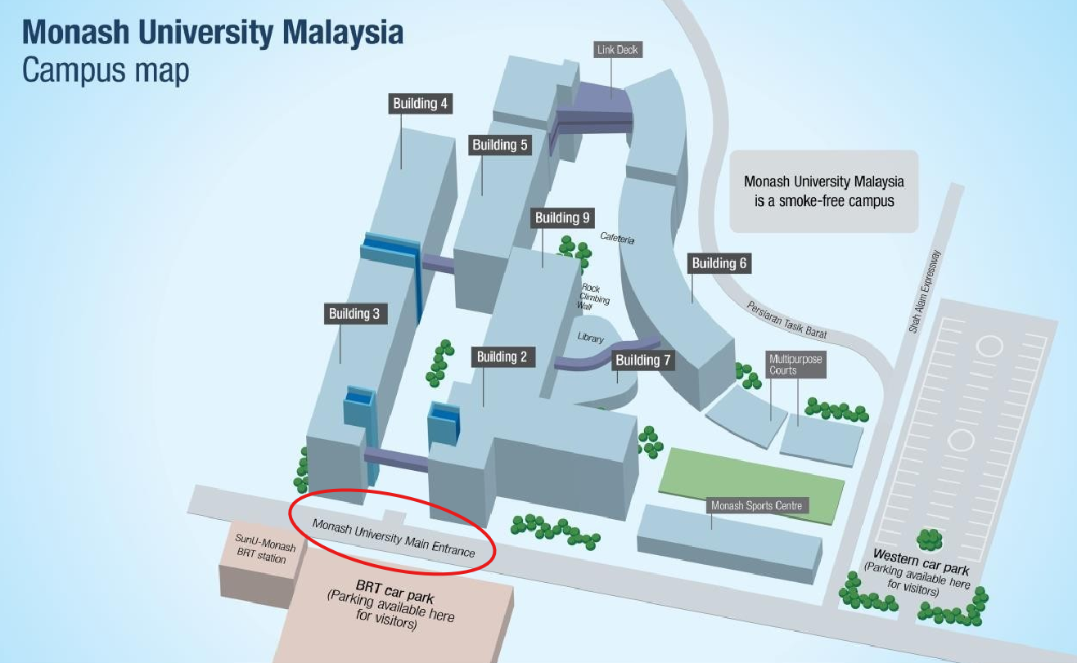

Shuttle Schedule
23 JUNE 2026
DEPARTURE LOCATION | DEPARTURE TIME | ARRIVAL LOCATION
Le Méridien Petaling Jaya | 7:00 | Monash University
Le Méridien Petaling Jaya | 7:15 | Monash University
Le Méridien Petaling Jaya | 7:30 | Monash University
Le Méridien Petaling Jaya | 7:45 | Monash University
Le Méridien Petaling Jaya | 8:00 | Monash University
Le Méridien Petaling Jaya | 8:15 | Monash University
Le Méridien Petaling Jaya | 8:30 | Monash University
Le Méridien Petaling Jaya | 8:45 | Monash University
Le Méridien Petaling Jaya | 9:00 | Monash University
Monash University | 17:20 | Le Méridien Petaling Jaya
Monash University | 17:35 | Le Méridien Petaling Jaya
Monash University | 18:00 | Le Méridien Petaling Jaya

24 JUNE 2026
DEPARTURE LOCATION | DEPARTURE TIME | ARRIVAL LOCATION
Le Méridien Petaling Jaya | 7:45 | Monash University
Le Méridien Petaling Jaya | 8:00 | Monash University
Le Méridien Petaling Jaya | 8:15 | Monash University
Le Méridien Petaling Jaya | 8:30 | Monash University
Le Méridien Petaling Jaya | 8:45 | Monash University
Le Méridien Petaling Jaya | 9:00 | Monash University
Le Méridien Petaling Jaya | 9:15 | Monash University
Le Méridien Petaling Jaya | 9:30 | Monash University
Le Méridien Petaling Jaya | 9:45 | Monash University
Monash University | 16:15 | Le Méridien Petaling Jaya
Monash University | 16:30 | Le Méridien Petaling Jaya
Monash University | 16:45 | Le Méridien Petaling Jaya
Monash University | 17:00 | Le Méridien Petaling Jaya
Monash University | 17:15 | Le Méridien Petaling Jaya
Monash University | 17:30 | Le Méridien Petaling Jaya
Monash University | 17:50 | Le Méridien Petaling Jaya
Monash University | 18:05 | Le Méridien Petaling Jaya
Monash University | 18:20 | Le Méridien Petaling Jaya

25 JUNE 2026
DEPARTURE LOCATION | DEPARTURE TIME | ARRIVAL LOCATION
Le Méridien Petaling Jaya | 7:45 | Monash University
Le Méridien Petaling Jaya | 8:00 | Monash University
Le Méridien Petaling Jaya | 8:15 | Monash University
Le Méridien Petaling Jaya | 8:30 | Monash University
Le Méridien Petaling Jaya | 8:45 | Monash University
Le Méridien Petaling Jaya | 9:00 | Monash University
Le Méridien Petaling Jaya | 9:15 | Monash University
Le Méridien Petaling Jaya | 9:30 | Monash University
Le Méridien Petaling Jaya | 9:45 | Monash University
Monash University | 14:30 | Le Méridien Petaling Jaya
Monash University | 14:45 | Le Méridien Petaling Jaya
Monash University | 15:15 | Le Méridien Petaling Jaya
Monash University | 15:30 | Le Méridien Petaling Jaya
Monash University | 17:00 | Le Méridien Petaling Jaya
Monash University | 17:15 | Le Méridien Petaling Jaya
Monash University | 17:45 | Le Méridien Petaling Jaya
Monash University | 18:00 | Le Méridien Petaling Jaya
Monash University | 18:30 | Le Méridien Petaling Jaya
Monash University | 18:45 | Le Méridien Petaling Jaya
Monash University | 19:15 | Le Méridien Petaling Jaya
Monash University | 19:30 | Le Méridien Petaling Jaya

26 JUNE 2026
DEPARTURE LOCATION | DEPARTURE TIME | ARRIVAL LOCATION
Le Méridien Petaling Jaya | 7:45 | Monash University
Le Méridien Petaling Jaya | 8:00 | Monash University
Le Méridien Petaling Jaya | 8:15 | Monash University
Le Méridien Petaling Jaya | 8:30 | Monash University
Le Méridien Petaling Jaya | 8:45 | Monash University
Le Méridien Petaling Jaya | 9:00 | Monash University
Le Méridien Petaling Jaya | 9:15 | Monash University
Le Méridien Petaling Jaya | 9:30 | Monash University
Le Méridien Petaling Jaya | 9:45 | Monash University
Monash University | 15:00 | Le Méridien Petaling Jaya
Monash University | 15:15 | Le Méridien Petaling Jaya
Monash University | 15:45 | Le Méridien Petaling Jaya
Monash University | 16:00 | Le Méridien Petaling Jaya
Monash University | 16:30 | Le Méridien Petaling Jaya
Monash University | 16:45 | Le Méridien Petaling Jaya

